A PROJECT REPORT

ON

LifeOS

web-based personal productivity and planning application
Submitted by
Gulafsha Khatoon Mohammed Mubeen Khan
Roll No: 26/CS-10 | Division: A

in partial fulfillment for the award of the degree of
BACHELOR OF SCIENCE
in
COMPUTER SCIENCE

Under the Guidance of
[Insert Guide Name Here]

Department of Computer Science

Bhartiya Gramin Punarrachana Sanstha's
MUMBAI COLLEGE OF ARTS, COMMERCE & SCIENCE
J.K. Jadhav Knowledge Centre, Nadkarni Park, Wadala (E), Mumbai - 400 037

Academic Year: 2026–2027

CERTIFICATE

This is to certify that Gulafsha Khatoon Mohammed Mubeen Khan(Roll No: 26/CS-10, Division: A), a student of T.Y.B.Sc. Computer Science, has satisfactorily completed the project entitled “LifeOS is a web-based personal productivity and planning application” during the academic year 2026–2027, in partial fulfillment of the requirements for the award of the Bachelor of Science degree in Computer Science.
The work presented in this report is submitted for academic evaluation and demonstrates the design and implementation of a real-time messaging application using HTML/CSS/JavaScript interface on the client side, and SQLite for persistent storage.

Project Guide Signature of Examiner

Head / In-charge Principal

DECLARATION

I, Gulafsha Khatoon Mohammed Mubeen Khan, hereby declare that the project entitled “LifeOS is a web-based personal productivity and planning application” submitted in partial fulfillment for the award of Bachelor of Science in Computer Science is my academic project work. The report describes the implementation and design of the application and has been prepared for academic submission.
I further declare that the information presented in this report is intended to describe the implemented project and its current capabilities. External technologies, frameworks and documentation used in the development have been acknowledged in the References section.

Student Signature: Name: Gulafsha Khatoon Mohammed Mubeen Khan Roll No.: 26/CS-10
Place: Mumbai
Date: 22 September 2026

ACKNOWLEDGEMENT

I would like to express my sincere gratitude to my project guide, faculty members and the Department of Computer Science for their guidance and support during the development of this project.
I am thankful to my college for providing the academic environment and resources required to study web development, databases, networking and software engineering concepts. I also thank my classmates, friends and family for their encouragement and for helping me test the application during development.
Finally, I would like to acknowledge the open-source technologies and documentation that helped me understand and implement the project.

Gulafsha Khatoon Mohammed Mubeen Khan
T.Y.B.Sc. Computer Science

ABSTRACT

LifeOS is a web-based personal productivity and planning application designed to bring task management, goal tracking, daily habits, calendar deadlines, focus sessions, and progress analytics into one workspace. The application is built with Python and Flask on the server side, an HTML/CSS/JavaScript interface on the client side, and SQLite for persistent storage. Its purpose is to help users organise daily work, see what needs attention, and develop consistent routines through a clear visual dashboard.
The dashboard summarises tasks, completed work, focus time, and habits completed today. A Kanban board groups tasks into To do, In progress, and Completed states. Users can assign categories, priorities, and due dates, while the calendar view presents upcoming deadlines. Habit check-ins are recorded by date, and the focus timer supports focus and break sessions. Analytics presents recent activity and task-state breakdowns. The application also provides CSV export for task records.
The source code defines API routes for creating, updating, deleting, and retrieving records, with input validation and SQLite foreign-key enforcement. The supplied database contains the expected tables but currently has no task, goal, habit, habit-log, or focus-session records; therefore, this report describes implemented functionality from the source code and does not claim measured user outcomes or performance results.

TABLE OF CONTENTS

Section | Contents | Page
1 | Introduction | 7
2 | Existing and Proposed System | 8
3 | Requirements and Objectives | 9
Figure 1 | Use Case Diagram | 10
4 | Technology Stack and System Architecture | 11
Figure 2 | Component / Architecture Diagram | 12
5 | Database Design and Data Management | 13
Figure 3 | Database ER Diagram | 14
6 | Application Modules and Functionalities | 15
Figure 4 | Task Creation Activity Diagram | 16
7 | User Interface and Navigation | 17
8 | API Design and Validation | 18
Figure 5 | Task Creation Sequence Diagram | 19
9 | Testing and Results | 20
10 | Security, Ethics and Limitations | 21
11 | Future Scope | 22
12 | Conclusion | 23
References | Technical references | 24
Glossary | Key terms | 25
Appendix | Database and API summary | 26

CHAPTER 1: INTRODUCTION

Background
Managing personal responsibilities often requires switching between separate tools for tasks, deadlines, routines, and focused work. When information is scattered, users may lose track of priorities or find it difficult to review progress. LifeOS addresses this problem by combining these related activities in a single browser-based workspace.

Problem Statement
A user needs a practical way to record tasks, prioritise work, track deadlines, build habits, and review productivity without maintaining multiple independent lists. The system should provide quick updates and retain information between visits.

Objectives
    - Provide a dashboard summarising tasks, focus sessions, and daily habit completion.
    - Support task creation, editing, deletion, categories, priorities, due dates, and workflow status.
    - Record goals and habit check-ins in a persistent database.
    - Offer calendar and analytics views for reviewing work and consistency.
    - Provide a focus timer with focus and break modes.
    - Allow task records to be exported in CSV format.

Scope
LifeOS is a personal productivity application. The inspected source implements local data storage and application routes for tasks, goals, habits, and focus sessions.
Authentication, multi-user collaboration, cloud synchronisation, and external calendar integration are not demonstrated in the supplied files and are outside the verified current scope.

CHAPTER 2: EXISTING AND PROPOSED SYSTEM

Existing Approach
A common approach is to use separate notes, calendar entries, habit trackers, and timers. This can create duplicated information and makes it harder to see how daily actions contribute to broader productivity. Manual tracking may also make historical review inconvenient.

Proposed System
LifeOS combines the core planning activities in a unified interface. The Overview page provides a high-level summary, while dedicated views organise tasks, calendar deadlines, habits, analytics, and focus sessions. Data is stored in SQLite and accessed through Flask endpoints.

Aspect | Separate/manual tools | LifeOS approach
Task workflow | Lists may not show status clearly | Kanban columns for To do, In progress, Completed
Deadlines | Scattered calendar entries | Calendar and upcoming-deadline view
Habits | Manual streak calculations | Dated habit logs and streak calculation
Focus | Independent timer or notes | Focus-session records and dashboard totals
Review | Manual counting | Weekly activity and task breakdown displays

Benefits
The design reduces context switching, makes task status visible, supports consistent habit check-ins, and provides a simple way to review activity. Benefits depend on regular and accurate user input.

CHAPTER 3: REQUIREMENTS AND OBJECTIVES

Functional Requirements
    - Retrieve current tasks, goals, active habits, weekly activity, and focus statistics.
    - Create a task with title, category, priority, optional due date, and status.
    - Update task fields and delete tasks by identifier.
    - Create goals, toggle goal completion, and remove goals.
    - Create habits, log or undo today’s check-in, and delete habits.
    - Record focus or break sessions with a duration from 1 to 180 minutes.
    - Export task information as a CSV file.
    - Display calendar, Kanban, habit, analytics, and focus views.

Non-functional Requirements
    - Usability: controls and labels should make common actions understandable.
    - Data integrity: relational constraints should protect habit-log references.
    - Validation: required titles, allowed values, and date formats should be checked.
    - Maintainability: application routes and database operations should remain organised.
    - Responsiveness: the stylesheet includes layouts for desktop, tablet, and mobile widths.

Hardware and Software Requirements

Component | Requirement / technology
Runtime | Python environment capable of running Flask
Web framework | Flask
Database | SQLite
Client | Modern browser with JavaScript enabled
Frontend | HTML, CSS, JavaScript
Fonts | DM Sans and Space Grotesk loaded from Google Fonts when available

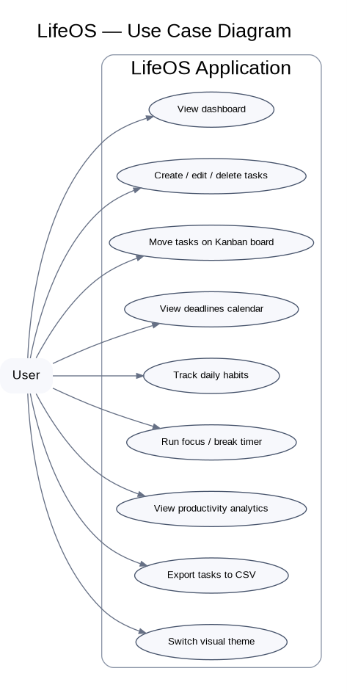
FIGURE 1: USE CASE DIAGRAM

LifeOS Project Report | 10
LifeOS Project Report | 10

CHAPTER 4: TECHNOLOGY STACK AND SYSTEM ARCHITECTURE
LifeOS Project Report | 10

Technology | Role in LifeOS
Python | Application logic, date handling, CSV generation, database access
Flask | HTTP routes, template rendering, JSON API responses
SQLite | Persistent storage for tasks, goals, habits, logs, and focus sessions
HTML | Structure of the dashboard and module views
CSS | Layout, themes, responsive behaviour, and visual styling
JavaScript | Client-side interaction and API communication (app.js is referenced by the page)
CSV | Portable export format for task records

Architecture
The application follows a lightweight client-server structure. The browser loads the main HTML template and its stylesheet and JavaScript. Flask serves the page and exposes API endpoints. Route handlers validate incoming data, execute parameterised SQLite queries, and return JSON or a CSV response. The database file is stored alongside the Python application.

Request Flow

Step | Description
1. User action | User submits a form or interacts with a view.
2. HTTP request | Client sends a request to a Flask route.
3. Validation | Server checks required fields, accepted categories/statuses, and date formats.
4. Database operation | SQLite inserts, updates, selects, or deletes the relevant records.
5. Response | Flask returns JSON, an error status, or a CSV download.
6. Interface update | Client-side code can refresh the view using returned data.

LifeOS Project Report | 11

LifeOS Project Report | 12

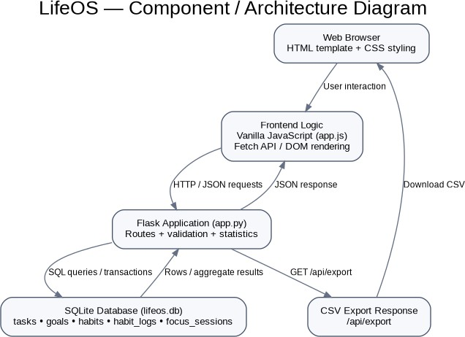

LifeOS Project Report | 12

CHAPTER 5: DATABASE DESIGN AND DATA MANAGEMENT
LifeOS Project Report | 11
The database schema is initialised by the Flask application. Tables are created when absent, and the task table includes a migration routine that adds status, priority, and updated_at columns to an older schema without dropping existing data.

Table | Important fields | Purpose
tasks | id, title, category, due_date, completed, status, priority, created_at, updated_at | Task details and workflow state
goals | id, title, completed, created_at | Personal goals and completion flag
habits | id, title, color, created_at, active | Habit definitions and active state
habit_logs | id, habit_id, log_date; unique(habit_id, log_date) | One check-in per habit per date
focus_sessions | id, mode, duration_minutes, completed_at | Recorded focus and break sessions

Relationships and Integrity
Each habit log references a habit through habit_id. The foreign key is configured with ON DELETE CASCADE, so deleting a habit removes its associated logs. A uniqueness constraint prevents duplicate logs for the same habit and date. SQLite foreign-key enforcement is enabled for each connection.

Data Validation
Task and goal/habit titles are required and limited to 150 characters. Task categories are restricted to Study, Work, Personal, Health, and Other. Priority values are Low, Medium, High, and Urgent. Task status is limited to todo, progress, or done. Due dates must use the YYYY-MM-DD format.

LifeOS Project Report | 13

LifeOS Project Report | 14

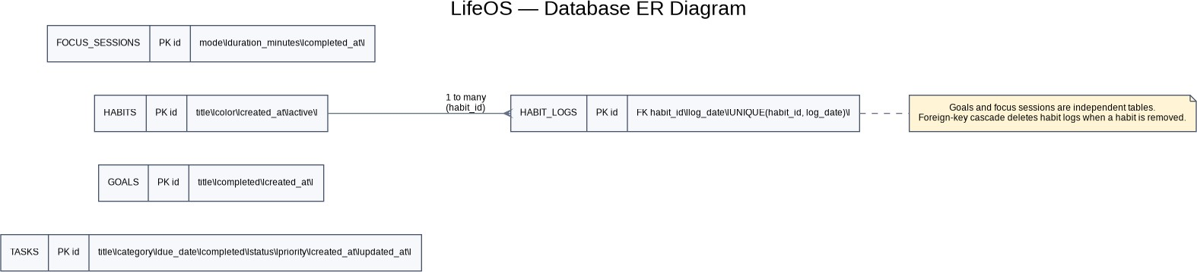

LifeOS Project Report | 14

CHAPTER 6: APPLICATION MODULES AND FUNCTIONALITIES
LifeOS Project Report | 12

Overview Dashboard
The Overview screen presents total tasks, completed tasks, focus minutes for the current day, habit check-ins, priority tasks, a focus-session preview, and a seven-day activity chart. Empty-state text guides the user when no priority tasks are available.

Task and Kanban Management
Tasks contain a title, category, optional due date, completion flag, workflow status, priority, and timestamps. The Kanban interface divides work into To do, In progress, and Completed columns. Task search and priority/category filters are represented in the interface. The server keeps the legacy completed flag synchronised with the done status.

Goals
Users can create a goal, toggle its completed state, and delete it. Goal records are stored separately from task records so that longer-term aims are not conflated with individual tasks.

Habit Tracking
A habit has a title, colour, creation timestamp, and active flag. The check-in endpoint adds or removes the current date from habit_logs. The data endpoint returns whether each active habit is done today, a seven-day history, and the current streak. A streak can continue when the most recent completion was today or yesterday.

Focus Timer
The interface provides focus, short-break, and long-break modes. The backend accepts focus or break session records with durations from 1 to 180 minutes.
Dashboard statistics sum focus-mode minutes for the current day and count all-time focus sessions.

LifeOS Project Report | 15

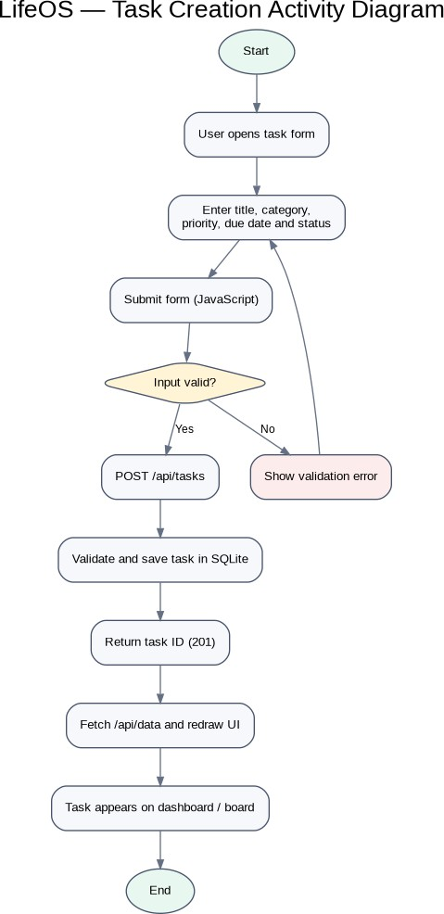
FIGURE 4: TASK CREATION ACTIVITY DIAGRAM

LifeOS Project Report | 16
LifeOS Project Report | 16

CHAPTER 7: USER INTERFACE AND NAVIGATION
The HTML template defines a sidebar navigation and a main content area. The navigation includes Overview, Kanban board, Calendar, Habits, Analytics, and Focus timer. A theme toggle is provided in the workspace profile area.

View | Purpose
Overview | Summary cards, priority tasks, focus preview, weekly activity
Kanban board | Task cards grouped by workflow status; search and filters
Calendar | Month navigation, due-date display, upcoming deadlines
Habits | Habit cards, weekly check-in marks, streak and progress summary
Analytics | Completed tasks, focus totals, completion percentage and status breakdown
Focus timer | Focus/break modes, timer controls, daily and all-time focus statistics

Visual Design
The stylesheet defines a dark purple dashboard palette with panels, borders, status colours, progress tracks, cards, and modal forms. A light theme can be activated by applying the body.light class. Media queries adjust the sidebar and content layout at narrower viewport widths.

Accessibility and Usability Notes
Controls include descriptive labels and several buttons provide accessible labels or title text. Further review should verify keyboard navigation, focus visibility, colour contrast, and screen-reader announcements across every dynamic interaction.

CHAPTER 8: API DESIGN AND VALIDATION

Method and endpoint | Purpose
GET / | Render the main interface
GET /api/data | Return tasks, goals, active habits, weekly summaries, and statistics
POST /api/tasks | Create a task
PATCH /api/tasks/{id} | Update allowed task fields
DELETE /api/tasks/{id} | Delete a task
POST /api/goals | Create a goal
PATCH /api/goals/{id} | Toggle goal completion
DELETE /api/goals/{id} | Delete a goal
POST /api/habits | Create a habit
POST /api/habits/{id}/check | Toggle today’s habit check-in
DELETE /api/habits/{id} | Delete a habit
POST /api/focus | Save a focus or break session
GET /api/export | Download task data as CSV

Error Handling
The API returns client-error responses for missing or invalid titles, invalid dates, invalid categories/priorities/statuses, invalid durations, missing records, and empty update requests. Responses include a JSON error message for the client to display.

Export
The export endpoint writes task ID, title, category, priority, status, due date, and creation time to CSV. A UTF-8 byte-order mark is prepended to improve compatibility with spreadsheet software.

LifeOS Project Report | 19

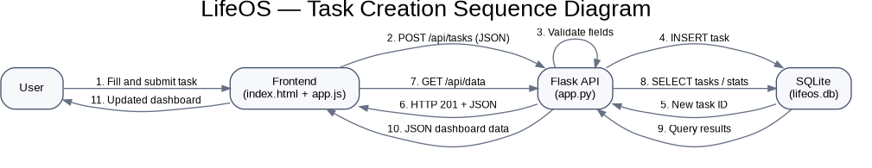

LifeOS Project Report | 19

CHAPTER 9: TESTING AND RESULTS
The supplied source code supports a functional test plan, but no executed test report or populated application dataset was supplied. The SQLite database currently contains zero records in tasks, goals, habits, habit_logs, and focus_sessions. Accordingly, numerical performance claims and user-outcome claims are not reported.

Test case | Expected behaviour based on source | Evidence status
Load home page | Flask renders index.html | Route defined; runtime test not supplied
Create valid task | New task ID returned with HTTP 201 | Handler implemented; execution not independently measured
Empty task title | HTTP 400 with validation message | Validation present in source
Invalid due date | HTTP 400 response | Date parsing validation present
Update unknown task | HTTP 404 response | Row-count check present
Toggle habit twice | First call logs date; second removes it | Handler implemented; runtime test not supplied
Delete habit | Habit and linked logs removed | Foreign-key cascade configured
Export CSV | CSV download with task headings | Export route implemented
Focus duration outside 1–180 | Validation error | Range check present

Results Summary
Source inspection confirms that the application defines the main CRUD endpoints and the database schema needed for tasks, goals, habits, habit logs, and focus sessions. It also defines summary calculations and CSV export. Full acceptance testing should be carried out in a running environment before claiming all user-interface workflows work end to end.

Suggested Acceptance Procedure
Run the Flask application in a test environment, create representative records, exercise each interface action, verify persistence after refresh, inspect error responses, test responsive layouts, and confirm that exported CSV values match stored task records.
Record actual results, browser details, and any defects found.

CHAPTER 10: SECURITY, ETHICS AND LIMITATIONS

Security Considerations
    - The supplied code does not show user authentication or role-based access control; the application should be treated as a local prototype unless access controls are added.
    - The development entry point runs Flask with debug=True; debug mode should be disabled for production deployment.
    - Deployments should restrict network exposure, protect the database file, and use HTTPS where traffic crosses untrusted networks.
    - Input validation is present for titles, task categories, priorities, statuses, due dates, and focus durations.
    - Database queries generally use parameter binding for user-supplied values.

Privacy and Data Handling
LifeOS may store personal task titles, goals, habits, and productivity history. A deployed version should explain what is stored, where it is stored, who can access it, and how users can export or delete it. The supplied implementation uses a local SQLite file and does not demonstrate a remote analytics service.

Limitations
    - The supplied database is empty, so no real usage trends can be concluded.
    - The uploaded HTML references static/app.js, but that JavaScript file was not among the supplied files; client-side event handling could not be fully audited.
    - No authentication, multi-user model, automated backups, or cloud synchronisation is evidenced in the inspected files.
    - The focus endpoint records a session when called; timer completion behaviour in the browser requires verification with the missing client script.
    - Testing and deployment results must be collected empirically rather than inferred from source code.

CHAPTER 11: FUTURE SCOPE
    - Add secure authentication and per-user data separation if multi-user use is required.
    - Provide automated database backups and a documented restore procedure.
    - Add recurring tasks, reminders, and configurable notification settings.
    - Allow users to set measurable goals and link tasks to goals.
    - Add richer analytics for habit consistency, category distribution, and focus history.
    - Improve accessibility through keyboard testing, semantic status announcements, and contrast checks.
    - Add automated unit and integration tests for API validation and database operations.
    - Complete and review the client-side JavaScript, then test every interaction across major browsers.
    - Consider calendar import/export and secure synchronisation only where there is a clear user need.

11.1 Deployment Readiness
Before deployment, the project should use a production WSGI server, disable debug mode, configure logging, define backup and recovery procedures, and document installation steps. A release checklist should include dependency versions, database migration checks, security review, and user acceptance testing.

CHAPTER 12: CONCLUSION
LifeOS is a personal productivity web application that brings task planning, goal records, habit tracking, deadline visibility, focus-session recording, and analytics into one interface. Its implementation uses Flask for server routes, SQLite for persistence, and HTML/CSS with a referenced JavaScript file for the browser interface. The task workflow supports categories, priorities, due dates, and three Kanban states, while habit logs provide daily check-ins and streak calculations.
The supplied source code contains validation and data-management logic for the principal modules, as well as a CSV export route. However, the provided database is empty and the client-side JavaScript file was not supplied for inspection. For that reason, this report distinguishes implemented source-code features from runtime behaviour that still needs testing. The next stage should be a documented test run with sample records, followed by security and deployment checks.

Project Outcome
The current deliverable establishes a clear, extensible foundation for a unified personal command centre. With end-to-end testing, client-side verification, and deployment hardening, LifeOS can be evaluated as a practical tool for organising daily responsibilities and reviewing personal productivity.

REFERENCES
Flask Documentation. Flask Web Development Framework. https://flask.palletsprojects.com/
Python Documentation. Python Standard Library. https://docs.python.org/3/
SQLite Documentation. SQL Language and Database Engine. https://www.sqlite.org/docs.html
MDN Web Docs. HTML, CSS, JavaScript, and HTTP documentation. https://developer.mozilla.org/
Google Fonts. DM Sans and Space Grotesk typefaces. https://fonts.google.com/
Note: These references identify the technologies directly used or referenced by the supplied project files. No external libraries beyond those visible in the supplied source have been assumed.

GLOSSARY

Term | Meaning
API | Application Programming Interface used for communication between client and server.
CRUD | Create, Read, Update, and Delete operations.
CSV | Comma-separated values, a plain-text data export format.
Flask | Python web framework used to serve pages and API endpoints.
Kanban | Workflow board that organises tasks by status.
SQLite | Embedded relational database stored in a file.
Habit log | Record that a habit was checked off on a particular date.
Focus session | Stored record of a focus or break duration.
Endpoint | URL and HTTP method used to access an application function.
Responsive design | Layout that adapts to different screen sizes.

APPENDIX — DATABASE AND API SUMMARY

Database Tables
The database initialisation code creates five principal tables: tasks, goals, habits, habit_logs, and focus_sessions. The task table includes a compatibility migration that adds status, priority, and updated_at when missing. It maps older completed values into Kanban status and then synchronises the completed flag with status.

Data Export Fields
The CSV export includes ID, Title, Category, Priority, Status, Due date, and Created. The download filename is lifeos_tasks.csv.

Important Validation Rules

Field | Rule
Task/goal/habit title | Required; maximum 150 characters
Task category | Study, Work, Personal, Health, or Other
Task priority | Low, Medium, High, or Urgent
Task status | todo, progress, or done
Due date | Valid YYYY-MM-DD date or blank
Focus session | Mode focus/break; duration 1–180 minutes

Supplied Database Snapshot
At the time this report was prepared, the supplied SQLite database contained 0 rows in tasks, goals, habits, habit_logs, and focus_sessions. This is a snapshot of the supplied file, not a claim about future use.
End of Report

